Breakfast All Day  Power Bowl (GF) 10  Chopped Bacon & Sausage, 3 Scrambled Eggs, Cheddar Cheese, House made Salsa served hot over wilted spinach  Avocado Toast (V+) 7  Avocado Mash on our European Style  Multigrain Bread with Avocado Slices and Everything Bagel Seasoning  Additions: Egg 1| Bacon 2 |Cheese 1 | Tomato 1  Breakfast Handhelds  On choice of Bagel, English Muffin, Multigrain, White or Wrap. GF Wrap available +1.  Egg & Cheese 5  2 Eggs and Cabot Cheddar  With Avocado, Bacon or Sausage 7.5  Breakfast Burrito 10  2 Eggs Scrambled, Onion, Pepper, Black Beans, Avocado Mash, Shredded Cheddar, House made Salsa on the Side  With Bacon or Sausage 12.5  American Plate 7  Eggs your way, choice of meat and toast  Vegan Sammy 10  House-made Roasted Garlic Hummus, Caramelized Onions, Grilled Tomato and Spinach on your choice of bread (V+)  Acai Bowls  Martha’s blend of frozen blueberries, acai, bananas, and almond milk with your choice of 3 toppings 11  Each additional topping 1  Baked Goods  Muffins, Vegan Muffins (V+), Bagels,  English Muffins  Peanut Butter, Cream Cheese +.50  Kettle  Martha’s Award-Winning Chowder  Cup 5| Bowl 7  V+ = Vegan |V = Vegetarian  GF = Gluten Free| DF = Dairy Free  Please inform your server if anyone in your party has a food allergy. Consuming raw or undercooked meat, poultry, seafood, or eggs may increase your risk of foodborne illness. | Lunch  Mayan Bowl (V, GF) 11  Mixed Greens, Black Beans, Sweet Corn, Avocado, Red Pepper, Pickled Jalapenos, Queso Fresco, Quinoa, topped with Peppitas. Our Chipotle Lime Dressing on the side.  Roasted Vegetable Bowl (V+,GF, DF) 13  Warm Tri-Colored Quinoa topped with our Roasted Veggies of the Day, Crunchy Sunflower Seeds and our Lemon Vinaigrette  Garden Salad (V+,GF, DF) 10  Chopped Romaine, Tomatoes, Cucumber, Carrot, Red Pepper, Avocado, Purple Onion, Balsamic Vinaigrette  Caesar Salad 10  Chopped Romaine, Parmesan, Croutons and our Caesar Dressing  To Any of the Above Add Chicken, Turkey, or Bacon 3  Black Bean Burger 5 | Angus Burger 8  Handhelds  Served with our Homemade Chips or Lightly Dressed Greens. Upgrade to Waffle Fries or Sweet Potato Fries +2  Roast Veggie Wrap (V+) 11  Hummus, Spinach, Roast Veggies of the Day, Balsamic Reduction. In a Spinach Wrap. Add Cheese +1  Miss Figgy 12  Grilled Cabot Cheddar and Applewood Smoked Bacon with Fig Preserves. On Rustic White or Multigrain  Grilled Caprese 11 (V)  Basil Pesto, Tomato and Mozzarella. Grilled on Rustic White.  California Chicken 12  Your Choice of Turkey or Chicken, Ranch, Lettuce, Tomato, Sprouts, Multigrain. Add Bacon + Avocado +2.5  Chicken Pesto 11.5  House Roasted Chicken, Lettuce, Tomato, Pesto Mayo, Provolone on Ciabatta  Chicken Caesar Wrap 11  Burgers  Half Pound Angus Burger 13.5  Black Bean Burger (V,GF) 10.5  Serv on Brioche Bun with Lettuce, Tomato, Onion & Side  Just the Sandwich…no side  Grilled Cheese 6.5  BLT 8.5  PB&J 4.5  Sliced house roasted chicken, lettuce, tomato, mayo, Choice of bread 8

Combos
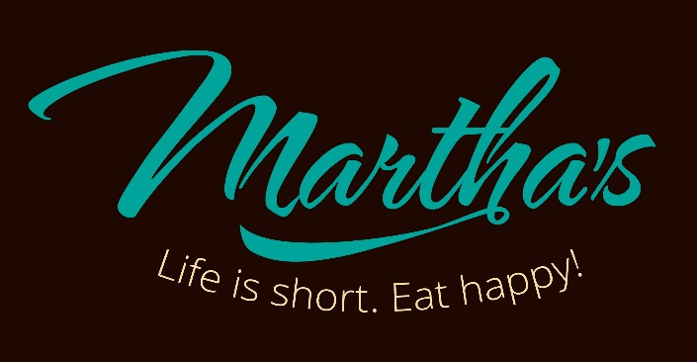
Cup and a Half
Half Sandwich - Chicken Salad, Cali Chicken or Turkey or BLT – Served with a Cup of Chowder or Small Side Salad 10

Beverages

Hot Drinks
Hot Jim’s Organic Coffee – regular or decaf 2/3
Breakfast and Lunch
served all day
Dine in or Take Out

Order On-Line www.marthascapecod.com
Espresso or Americano 4
Hot Cappuccino, Latte or Chai Tea Latte 4/5
Caffé Mocha 5.75
Add a Flavor Shot +.75
Whole, Skim or Almond Milk (+.50) available
Hot Chocolate 3

Cold Drinks
Jim’s Iced Coffee 2/3
House Made Iced Tea or Lemonade 2/3
Bottled Beverages in our cooler.
Martha’s is committed to making the world a better place. We serve local and/or organic when practicable; we make all our dressings in house; we compost and recycle, and want to work with you to reduce food and packaging waste.
Winter Hours
Friday-Wednesday 10-2

281 Main Street Falmouth, MA
774.763.2066

Cash payment is preferred
Menu and prices are subject to change
depending on market conditions. 5/22/20

Follow us on Social Media
Yelp.com/biz/marthas-falmouth
- Facebook.com/marthascapecod
Twitter.com/marthascapecod1
Instagram.com/marthas.capecod
www.marthascapecod.com

